**Experimental investigation on properties of hybrid nanofluids (TiO2 and ZnO) in water–ethylene glycol mixture**

**N.S.M. Sahid**1**, M.M. Rahman**1**, K. Kadirgama**1 **and M. A. Maleque2**

1Faculty of Mechanical Engineering, Universiti Malaysia Pahang

26600 Pekan, Pahang, Malaysia,

*Email: mustafizur@ump.edu.my

Phone: +6094246239; Fax: +609424222

2Department of Manufacturing and Materials Engineering

International Islamic University Malaysia

53100 Kuala Lumpur, MALAYSIA

**ABSTRACT**

This paper presents an experimental investigation on properties and stability of hybrid nanofluids (TiO2 and ZnO) in water-ethylene glycol mixture. The nanofluids are important in heat enhanced due to its inherent operative performance. The performance of hybrid nanofluids in mixture based fluids is not explored vigorously yet. The properties of TiO2 and ZnO nanoparticle dispersed in mixture of water and ethyelene glycol (EG) were considered in this study. The outcome of base fluid proportion (water: EG) to hybrid nanofluids was investigated. Hybrid nanofluids with different volume concentration up to 0.1-1.5% were prepared with 21nm particle size of TiO2 and 10-30nm ZnO nanoparticle. The nanoparticle were suspended in various ratio of TiO2 : ZnO including 70:30, 80:20 and 90:10 by volume percent. The measurements of viscosity were performed using Brookfield LVDV III Ultra Rheometer for hybrid nanofluid temperature of 50 to 70 oC, while the measurements of thermal conductivity were performed using KD2 PRO thermal conductivity. Viscosity and thermal conductivity of hybrid nanofluids were perceived to impact by hybrid nanofluids concentration, temperature and water-ethelene glycol as base fluid strongly.

Keywords: Hybrid nanofluids; thermal conductivity; temperature; ethylene glycol; titanium oxide; zinc oxide.

**INTRODUCTION**

An enhancement of the heat transfer surfaces, increasing the heat transfer of fluid flow, with high heat transfer coefficient and the use of hybrid fluids are of ways that the scientists proposed to increase heat transfer. Heat transfer process plays an vital role in different industries such as cooling and heating, machining, automotive, chemical reactions and solar collector applications, electrical power generation [1, 2]. The nanofluids are mainly utilized for the purposes of heat transfer enhancement, reducing in heat exchanger surface, the reduction of consumed fluids, the industries cost reduction and miniaturization of systems. According to the research, the nanofluids have unusual thermo-physical properties compared to the conventional fluids [3]. Two important properties of nanofluids are viscosity and thermal conductivity have been studied. It was suggested that lowering the temperature, increasing the grain size and the amount of nanoparticles dispersed in the base fluid can increase the viscosity of nanofluids [4]. Nowadays, demand need in various applications for fluids with more efficient heat transfer has been led to enhance heat transfer to meet the cooling challenge necessary [5]. The viscosity of hybrid nanofluids meaningfully affect the overall heat transfer performance which have been studied previously [6-10]. For further study on effect of base fluid and temperature to heat transfer characteristics found that the efficiency of nanofluids improve with increasing in the temperature [11]. The effectiveness is advanced for nanofluid suspension mixture base compare to water based. The authors used SiC nanoparticles dispersed in ethylene glycol-water mixture in volume ratio of 50:50 with Fe3O4 nanoparticles dispersed in three mixture of ethylene glycol/water ratio (60:40, 40:60 and 20:80) [8]. The authors observed that 1.0 % volume concentration nanofluid in 60:40 EG/W is enhanced by 2.94 % compared to other based fluids. Another mixture base fluid used in investigation is 55:45 (W:EG) [12]. The authors found that the temperature and volume concentration are deliberately affect the nanofluid viscosity. Then, the nanofluid exhibit Newtonian behaviours below 45°C [13]. Nanofluid studies that used TiO2 as the material in the dispersion are covered in both the thermo-physical property field and application in areas. TiO2 is widely used as the nanoparticles are safe and environmentally friendly materials and easily produced in very large industries. Thermal property of TiO2 nanofluids covered a wide concentration and temperature range by many researchers [14-16]. Most of the findings from those studies showed significant enhancement of thermal conductivity. Investigating the sensitivity of relative thermal conductivity of the nanofluids to concentration variations is more than its sensitivity to temperature changes. The objective of this study is to investigate the effect of hybrid nanofluid with different volume concentration towards viscosity and thermal conductivity in various ratio of mixture for temperature range of 50 to 70 °C. Investigation on rheological properties is very important to expand the application of hyrid nanofluids with addition of EG in the coolant of machining purpose. The selection of ZnO and TiO2 nanoparticle in 21nm particle size and 10-30nm ZnO are due to its more stability period.

**METHODS AND MATERIALS**

**Hybrid Nanofluids Preparation**

Hybrid nanofluids were used in the sample preparation are 21nm particle size and 10-30nm ZnO in powder form respectively. The nanoparticle were suspended in three different ratio of TiO2: ZnO nanosize which are 70:30, 80:20 and 90:10 by volume percent. The ratio base fluid were used 60:30 (EG:W). Two step method was used in the preparation of hybrid nanofluids. Sonication process was employed to help improve the dispersion of nanoparticles in the base fluid. The nanoparticles are dispersed in the base fluid using magnetic stirrer and sonicated in ultrasonic bath for two hours [16-18]. Samples prepared for ratio 90:10 of TiO2 and ZnO are found to be stable for three months. Equation (1) used to determine the mass of ZnO and TiO2 to disperse in the base fluid [19]. Figure 1 shows the process flow preparation of sample hybrid nanofluids with three different ratio of volume concentration.

 (1)

**Viscosity Measurement**

The viscosity was measured with Brookfield LVDV III Ultra Rheometer. The range of measurement is 1 to 6 ×106 mPa.s. Figure 2 shows the setup of the experiment for measures the viscosity. Rheometer to make accurate and reproducible measurements on low viscosity materials. Hybrid nanofluids with 16 ml volume sample was inserted into cylinder jacket and attached to the rheometer. A *RheoCal* program was installed for the data measurement at the designated torque and temperature. The sample was heated from 50 to 70 °C for viscosity measurement. To validate the data, the reading of the torque from the measurement must range in 10-100%.

**Thermal Conductivity**

The thermal conductivity of nanofluids is one of the reasons for the enhancement of heat transfer. She thermal conductivity of TiO2 and ZnO nanofluids experimentally. The large (100 mm long, 2.4 mm diameter) single needle TR-1 sensor from KD2Pro measures thermal conductivity and thermal resistivity was used. For the dual-needle sensor, the needles must remain parallel to each other during insertion to make an accurate reading. Because the sensors give off a heat pulse need allow a minimum of 1.5 cm of material parallel to the sensor in all directions. When the temperature of the sample is different from the temperature of the needle, the needle must equilibrate to the surrounding temperature before beginning a reading. Therefore, the calibration process was used with standard fluid (Glycerin) which was already brought with devices. To validate the data error of the reading from the measurement must less than 0.01.

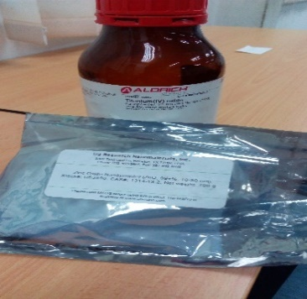 

Stirring the hybrid nanofluids

Hybrid nanoparticles

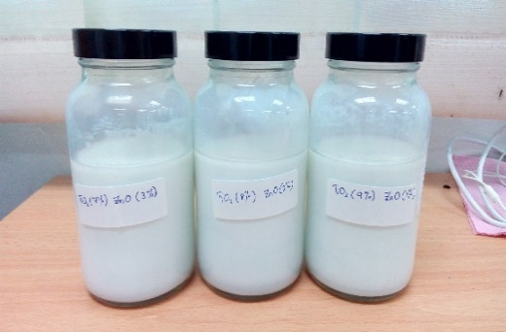 

Immersed in ultrasonic bath for 2 hours

Sample of hybrid nanofluids

Figure 1. Process flow in the preparation of hybrid nanofluids.



Sample Hybrid nano

Sample jacket

Spindle

Rheometer

Figure 2. Viscosity measurement with Brookfield Rheometer.

**RESULTS AND DISCUSSION**

The measurement of viscosity is initially started with the nanohybrid. Previous studies that use the same procedure [20, 21]. Figure 3 shows the Newtonian behaviour.Newtonian fluid is a [fluid](https://en.wikipedia.org/wiki/Fluid) in which the [viscous stresses](https://en.wikipedia.org/wiki/Viscous_stress_tensor) arising from its [flow](https://en.wikipedia.org/wiki/Fluid_dynamics), at every point, are linearly proportional to the local [strain rate](https://en.wikipedia.org/wiki/Strain_rate). The mixture of water and ethylene glycol shows Newtonian behavior hence it governs the rheological property and the nanofluid behaves like Newtonian [9]. In general, the hybrid nanofluids viscosity follows the base fluid trend where it decreases exponentially with temperature. However, as the nanoparticle mix with the base fluid increase, the viscosity value also is increased. This is the fact that increase in nanoparticle concentration in nanofluid increases the fluid internal shear stress, hence the viscosity [22]. From the graph shows in Figure 4, the hybrid nanofluids decrease with temperature. The relative viscosities of TiO2 and ZnO hybrid nanofluids are almost constant for volume concentration 70:30, 80:20, 90:10. All the hybrid nanofluids are independent of temperature at base fluid (W/EG). It can be observed for medium concentration in base fluid that contains higher EG, (W/EG) 40:60.



Figure 3. Newtonian behaviour.

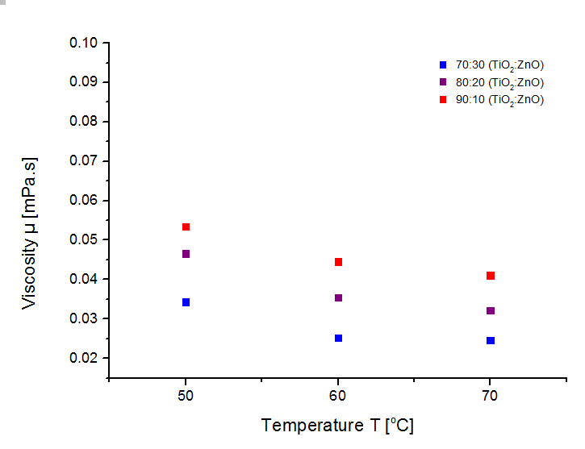

Figure 4. The viscosity of the hybrid nanofluids

Figure 5 shows, the thermal conductivity increased with the increase of volume concentrations and temperature, following the behaviour of the base fluid (W/EG) thermal conductivity. The maximum value was found to be at the condition where temperature and concentration are at the maximum which was at 70 °C. All thermal conductivity of the hybrid nanofluids at this concentration range was found increases. The observation of this results shows to be related to the Brownianmotion. When at high temperatures, the collision of particles happened at a higher rate, thus it is carried more kinetic energy. Hence, the thermal conductivity will increased [23, 24]. The same observation in hybrid nanofluids, thermal conductivity was encountered by researches with base fluid of water and EG mixture but with different nanoparticles [18, 25, 26]. Hamid et al. also reported the same thermal conductivity behaviour for TiO2 nanofluids in the mixed base fluid [27].

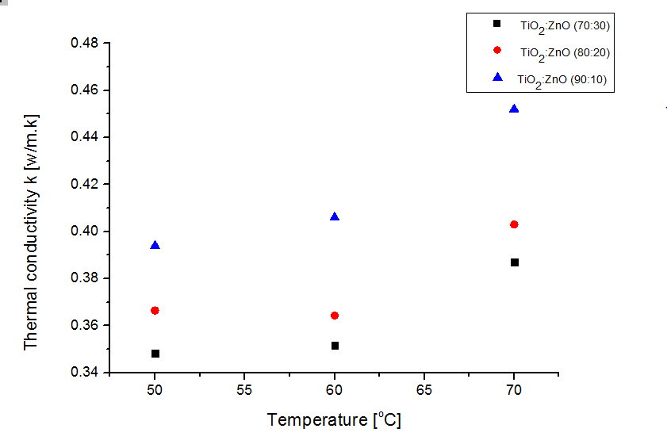

Figure 5. Thermal conductivity of hybrid nanofluids.

**Stability of Hybrid Nanofluids**

Many methods have been developed to evaluate the stability of hybrid nanofluids. The simplest method is sedimentation method [28]. The investigation on stability is a key issue that influences the properties of hybrid nanofluids for application. A new method is used to estimate the suspension concentration with the increasing the sediment time. Figure 6 shows the peak absorbance of hybrid nanofluids appears at 364 nm. The absorbance of hybrid nanofluids decreases with increasing sediment time.

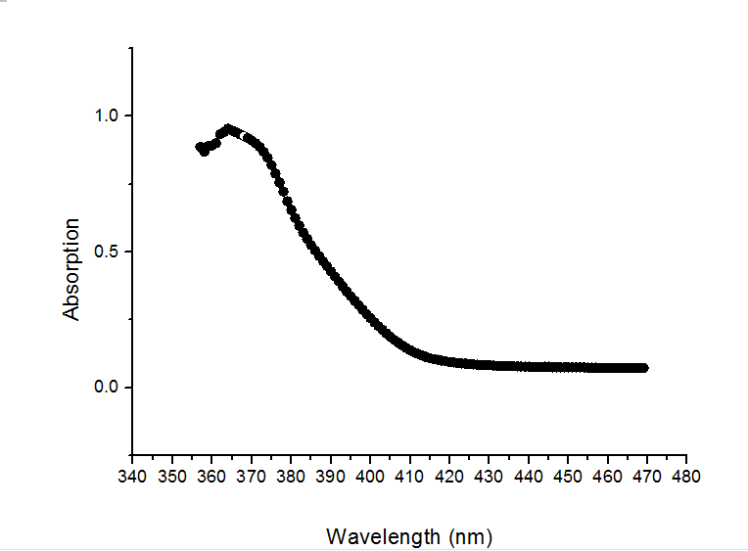

Figure 6. UV-spectophotometer spectrum of hybrid nanofluids.

**CONCLUSIONS**

In this study, the viscosity of hybrid nanofluids in water and EG based for three different ratios of mixture of hybrid are presented. The result indicates that the viscosity of hybrid nanofluids based water-EG are increased with increases of shear stress. The hybrid nanofluids viscosity constant exponentially with increases of temperature. The relative viscosities are independent with the temperature for all concentrations of TiO2 and ZnO. The results for the thermal conductivity of hybrid nanofluids shows enhancements with an increase in concentration and an increase in temperature. The distinction is higher at 90:10 volume concentration where the temperature dependence can be observed. It is more noticeable for higher concentration in TiO2. As the bulk temperature increases, the enhancement becomes more noticeable for higher concentrations. Hence the stability of hybrid nanofluids is strongly affected by the characteristics of the suspended particle and base fluids.

**ACKNOWLEDGEMENTS**

The authors would like to thank to the Universiti Malaysia Pahang for laboratory facilities and financial assistance under Fellowship Research Grant project No. RDU172203.

**REFERENCES**

[1] Esfe MH, Behbahani PM, Arani AAA, Sarlak MR. Thermal conductivity enhancement of SiO 2–MWCNT (85: 15%)–EG hybrid nanofluids. Journal of Thermal Analysis and Calorimetry. 2017;128:249-58.

[2] Verma SK, Tiwari AK. Progress of nanofluid application in solar collectors: a review. Energy Conversion and Management. 2015;100:324-46.

[3] Jafarmadar S, Azizinia N, Razmara N, Mobadersani F. Thermal analysis and entropy generation of pulsating heat pipes using nanofluids. Applied Thermal Engineering. 2016;103:356-64.

[4] Afrand M, Najafabadi KN, Akbari M. Effects of temperature and solid volume fraction on viscosity of SiO2-MWCNTs/SAE40 hybrid nanofluid as a coolant and lubricant in heat engines. Applied Thermal Engineering. 2016;102:45-54.

[5] Hussein AM, Bakar R, Kadirgama K, Sharma K. Experimental measurement of nanofluids thermal properties. International Journal of Automotive and Mechanical Engineering. 2013;7:850-63.

[6] Eastman JA, Phillpot S, Choi S, Keblinski P. Thermal transport in nanofluids 1. Annu Rev Mater Res. 2004;34:219-46.

[7] Das SK, Putra N, Thiesen P, Roetzel W. Temperature dependence of thermal conductivity enhancement for nanofluids. Journal of Heat Transfer. 2003;125:567-74.

[8] Sundar LS, Ramana EV, Singh M, De Sousa A. Viscosity of low volume concentrations of magnetic Fe 3 O 4 nanoparticles dispersed in ethylene glycol and water mixture. Chemical physics letters. 2012;554:236-42.

[9] Namburu PK, Kulkarni DP, Misra D, Das DK. Viscosity of copper oxide nanoparticles dispersed in ethylene glycol and water mixture. Experimental Thermal and Fluid Science. 2007;32:397-402.

[10] Nguyen C, Desgranges F, Roy G, Galanis N, Maré T, Boucher S, et al. Temperature and particle-size dependent viscosity data for water-based nanofluids–hysteresis phenomenon. International Journal of Heat and Fluid Flow. 2007;28:1492-506.

[11] Timofeeva EV, Yu W, France DM, Singh D, Routbort JL. Base fluid and temperature effects on the heat transfer characteristics of SiC in ethylene glycol/H2O and H2O nanofluids. Journal of Applied Physics. 2011;109, 014914.

[12] Yu W, Xie H, Li Y, Chen L, Wang Q. Experimental investigation on the heat transfer properties of Al2O3 nanofluids using the mixture of ethylene glycol and water as base fluid. Powder Technology. 2012;230:14-9.

[13] Hamid KA, Azmi W, Mamat R, Usri N, Najafi G. Investigation of Al 2 O 3 Nanofluid Viscosity for Different Water/EG Mixture Based. Energy Procedia. 2015;79:354-9.

[14] Masuda H, Ebata A, Teramae K. Alteration of thermal conductivity and viscosity of liquid by dispersing ultra-fine particles. Dispersion of Al2O3, SiO2 and TiO2 ultra-fine particles. 1993.

[15] Wen D, Ding Y. Natural convective heat transfer of suspensions of titanium dioxide nanoparticles (nanofluids). IEEE Transactions on Nanotechnology. 2006;5:220-7.

[16] Azmi W, Sharma K, Sarma P, Mamat R, Anuar S. Comparison of convective heat transfer coefficient and friction factor of TiO 2 nanofluid flow in a tube with twisted tape inserts. International Journal of Thermal Sciences. 2014;81:84-93.

[17] Azmi W, Sharma K, Sarma P, Mamat R, Najafi G. Heat transfer and friction factor of water based TiO2 and SiO2 nanofluids under turbulent flow in a tube. International Communications in Heat and Mass Transfer. 2014;59:30-8.

[18] Azmi W, Sharma K, Sarma P, Mamat R, Anuar S, Rao VD. Experimental determination of turbulent forced convection heat transfer and friction factor with SiO2 nanofluid. Experimental Thermal and Fluid Science. 2013;51:103-11.

[19] Sahid N, Rahman M, Kadirgama K, Ramasamy D, Maleque M, Noor M. Experimental investigation on the performance of the TiO2 and ZnO hybrid nanocoolant in ethylene glycol mixture towards AA6061-T6 machining. International Journal of Automotive & Mechanical Engineering. 2017;14:3913-26.

[20] Kulkarni DP, Namburu PK, Ed Bargar H, Das DK. Convective heat transfer and fluid dynamic characteristics of SiO2 ethylene glycol/water nanofluid. Heat Transfer Engineering. 2008;29:1027-35.

[21] Vajjha RS, Das DK, Kulkarni DP. Development of new correlations for convective heat transfer and friction factor in turbulent regime for nanofluids. International Journal of Heat and Mass Transfer. 2010;53:4607-18.

[22] Kole M, Dey T. Viscosity of alumina nanoparticles dispersed in car engine coolant. Experimental Thermal and Fluid Science. 2010;34:677-83.

[23] Keblinski P, Phillpot S, Choi S, Eastman J. Mechanisms of heat flow in suspensions of nano-sized particles (nanofluids). International Journal of Heat and Mass Transfer. 2002;45:855-63.

[24] Teng T-P, Hung Y-H, Teng T-C, Mo H-E, Hsu H-G. The effect of alumina/water nanofluid particle size on thermal conductivity. Applied Thermal Engineering. 2010;30:2213-8.

[25] Vajjha RS, Das DK. Experimental determination of thermal conductivity of three nanofluids and development of new correlations. International Journal of Heat and Mass Transfer. 2009;52:4675-82.

[26] Azmi W, Sharma K, Mamat R, Anuar S. Nanofluid properties for forced convection heat transfer: an overview. Journal of Mechanical Engineering and Sciences. 2013;4:397-408.

[27] Hamid KA, Azmi W, Mamat R, Sharma K. Experimental investigation on heat transfer performance of TiO2 nanofluids in water–ethylene glycol mixture. International Communications in Heat and Mass Transfer. 2016;73:16-24.

[28] Yu W, Xie H. A review on nanofluids: preparation, stability mechanisms, and applications. Journal of Nanomaterials. 2012;2012:1-17.