Invited Speakers
No | Invited Speaker | Biography
1 | 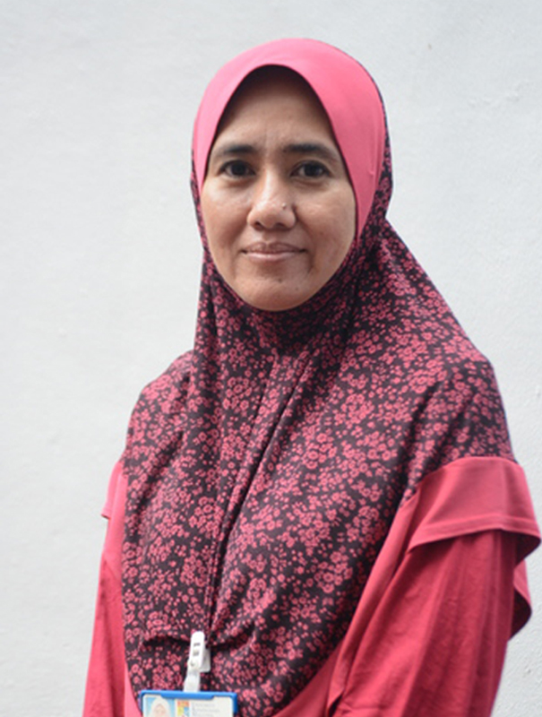  ASSOC. PROF. DR. SITI NORUL HUDA SHEIKH ABDULLAH  Chairperson of Center For Cyber Security (CYBER)  Faculty of Information Science & Technology,  Universiti Kebangsaan Malaysia(UKM)
2 | 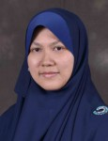  ASSOC. PROF. IR. DR. HAZLINA SELAMAT  Director of Centre for Artificial Intelligent and Robotics (CAIRO)  Faculty of Electrical Engineering  Universiti Teknologi Malaysia(UTM)
3 | 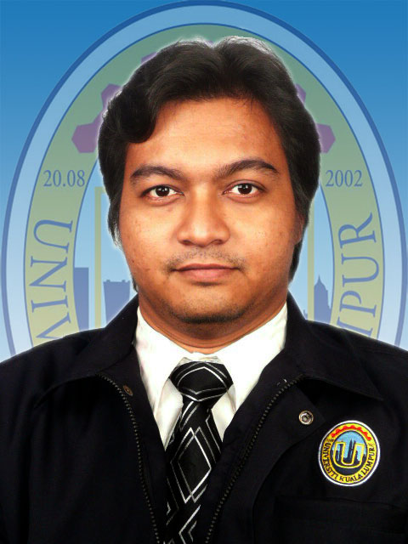  DR. ZALHAN BIN MOHD ZIN  Deputy Dean (International Industrial & Institutional Partnership)  Universiti Kuala Lumpur Malaysia France Institute (UniKL MFI)
4 | 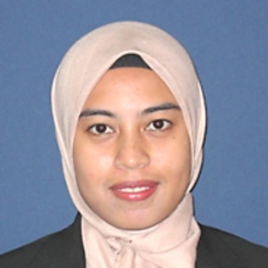  DR. JULIA ABDUL KARIM  Head of Nuclear Reactor Physics  Malaysian Nuclear Agency (ANM)
5 | 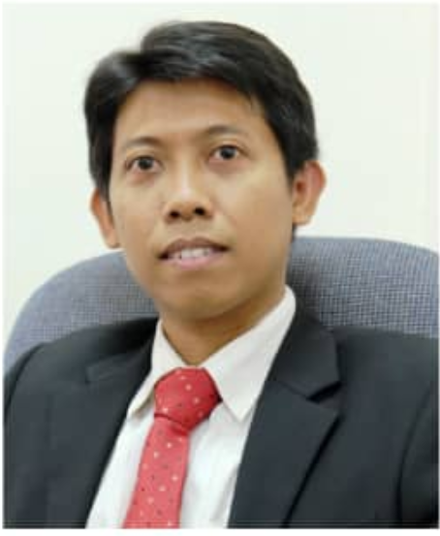  DR. SLAMET RIYADI  Department of Information Technology,  Universitas Muhammadiyah Yogyakarta(UMY), Indonesia
6. | 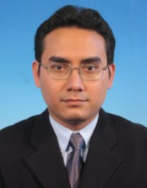  DR. MOHAMAD HANIF BIN MD SAAD  Faculty of Engineering and Built Environment,  Universiti Kebangsaan Malaysia(UKM)
7 | 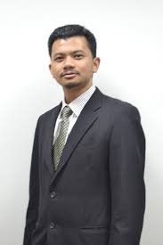  PROF. MADYA DR. SHAMSUL AIZAM BIN ZULKIFLI  Faculty of Electrical and Electronic Engineering,  Universiti Tun Hussein Onn Malaysia(UTHM) | Shamsul Aizam Zulkifli was born in Kajang, Selangor, Malaysia, in 1980. He received the BS and MSc degrees from the University Putra Malaysia (UPM) in 2003 and 2006, respectively, and a PhD degree in Control System Engineering from Loughborough University, UK, in 2012. He is currently an Associate Professor with the Department of Electrical Power Engineering, Faculty of Electrical and Electronic Engineering of Universiti Tun Hussein Onn Malaysia (UTHM). His research interest includes robust control system on power electronics application, parallel inverter application and smart grid topology for inverter-grid connection.  My personal homepage: https://sites.google.com/site/acul1508/
8
9

