Evaluation of Performance and Characteristic of Stingless Bee Honey Using MARDI’s Dehydrator
Amir Syariffuddeen, M.A., Azman, H. and Yahya, S.
Engineering Research Centre,
Persiaran MARDI-UPM, MARDI Head Quarters, 43400 Serdang, Selangor, Malaysia.
*Corresponding Author, Tel: +06 89536557, E-mail: asyariff.mardi@1govuc.gov.my

Abstract
Dehydration of stingless bee honey is a part of honey processing which is required to reduce moisture of honey. Fresh harvested stingless bee honey possessed high moisture level of 26-29%w/w and this can resulted to the fermentation of honey which is can effected the nutrients, active ingredients and its quality of the honey. It is important to reduce the moisture level of honey into its stable condition in range ≤20%w/w. A new dehydrator has been developed to replace the current technique for reducing moisture of honey. Based on the performance test on prototype implemented, it has found the dehydrator can reduce the moisture into appropriate moisture level (≤20%) only in 8 hours compared to the normal practice greater than 24 hours. Comparison on physicochemical analysis of fresh harvested and dehydrate honey resulted that there is not significant different between both sample. It has shown that sugar profile of dehydrated honey for fructose, glucose, and sucrose are 13.52 ± 0.75ª, 3.46 ± 0.21ª and 2.48 ± 0.13ª respectively, hydroxymethylfurfural (HMF) is 2.39, total phenolic compound (TPC) is 25.00 ± 0.57ª and viscosity 24.30 ± 0.20ª.
Keywords: Dehydrator, Stingless bee, Moisture, Kelulut, MARDI

Introduction
Stingless bee (Kelulut) are highly eusocial insects and can be found in most tropical and subtropical region of the world such as in Australia, Africa, Southeast Asia, meso-America and South America (Michener, 2013). More than 500 species of stingless bee species have been identified worldwide and it’s belonging to the Meliponinae species (Michener, 2013). The stingless bee exhibited different characteristics of the genus Apis and Bombus, especially its physical morphology with absence of the sting, collecting nectar from creeping plants, short distance in finding of food, construct hives in a horizontal position absence elaboration of honeycombs for the storage of nectar and pollen (Vit et al.,2013). Stingless bee honey become a precious products and its displayed different physical characteristic from honey that produced by the bees of the genus Apis (i.e: honey bee) in terms of its colour, taste and viscosity (Almeida-Muradian et al., 2014). In terms of chemical properties, stingless bee honey basically consisted of a complex mixture of carbohydrates, especially glucose and fructose, organic acids, amino acids, minerals, vitamins, enzymes, pollen and pigments (Carvalho et.al., 2009; Fallico et al., 2004). There is a problem has been faced by worldwide and domestic meliponiculture regarding to the conservation of stingless bee honey due to its high moisture content (Carvalho et al., 2009). High moisture content resulted in fermentation and consequent deterioration of quality and shelf life of the product. Currently, in Malaysia the existing technique to reduce the moisture content of stingless bee honey is different from one to another (i.e: double boiling, open drying and cabinet drying). Thus, it is required a standard technique and processing for this purpose to produce consistent high quality honey. Thus, considering the problem faced by stingless bee entrepreneurs regarding to honey conservation owing the high moisture content, the development of systematic dehydrator has promising to cater this problem. This work aimed to evaluate the performance of the dehydrator, characterized the physicochemical properties and quality of stingless bee honey subjected after dehydration process using this dehydrator.
Materials and methods
The development of dehydrator and experiments was conducted in the Postharvest Engineering Lab in Food Science Research Centre MARDI, Selangor, Malaysia. Honey samples for experiments were taken from stingless bee’s honey farm in Rembau, Negeri Sembilan.
Development of dehydrator
Development of dehydrator involved the fabrication works with the components such as domestic dehumidifier Firenzzi FDX-1800 (France), DC Motor DG90-F180090, 180V (Korea), Toyo 2.5x2.5 60 watt exhaust fan (USA) has integrated to the main body of dehydrator made of stainless steel. 3 level of food grade steel horizontal trays with internal diameter 37cm and its external diameter 50 mm has used as the sample displacement and has vertically arranged. A stirrer made of Teflon has attach to the dehydrator to increase the rate of dehydration process. The features of the dehydrator as shown in Figure 1.

- Collection of samples:
Stingless bee honey were collected from Rembau, Negeri Sembilan. The honey collected was come from honey that extracted from Trigona Iitama sp. colony. 15kg of honey has been collected for a batch run of experiments.

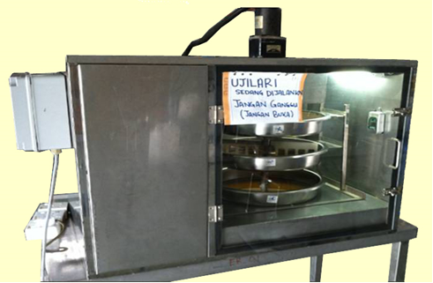
Figure 1: Dehydrator of stingless bee honey
- Dehydration process
15kg of stingless bee honey has divided into 3 trays and has weighed to 5kg for each tray. The dehydrator stirrer has installed and attached to the electric motor shaft and it followed by putting the tray filled with honey at the tray holder. Once the stirrer and tray has mounted, the dehydrator and its component has switch on. Temperature and humidity during dehydration process can be monitor on the screen at the panel controller box and both also has been recorded using Extech Instruments Temperature and Humidity Datalogger model 42270 (USA). To check the air distribution during dehydration process, the air velocity from the air that come out from dehumidifier has measured using TESTO 416 Anemometer (Switzerland). Moisture content of honey has been measured using ATAGO refractometer 12-26% Honey Moisture (Japan) for each 1 hour interval. The measuring process of moisture content was repeated until honey sample in each tray has reached the range of 18-20% moisture.

- Physicochemical Analysis
- Sugar profile determination using HPLC
For sugar profile analysis, the analysis was performed using Phenomenex Rezex Monosaccharide RPM Pb²⁺ column with 150mm long and 4.6mm diameter on Perkin-Elmer RI detector HPLC (USA). Mobile phase used were 100% water (v/v) at the flow rate 1.0 ml/min at operation temperature 30°C.

- HMF determination by HPLC method
5 grams of honey samples were diluted up to 50 ml with distilled water, filtered on 0.45µm filter and immediately injected in a UHPLC (Dionex Ultimate 3000) equipped with a RS Diode Array Detector (Dionex, Ultimate 3000). The UHPLC column was a Acclaim RSL C PA2, 21x150mm). The mobile phase consisted of 1.0 % formic acid (A) and acetonitrile (B). The gradient condition was as follows: 0 min, 5% B; 5 min, 28% B; 15 min, 90% B; 21 min, 5% B. The injection sample volume is 20µL at flow rate 0.3ml/min with wavelength 280nm. The temperature used for operation is at 30°C.

- Determination of total phenolic content
The levels of polyphenol compounds in the kelulut honey samples were estimated with spectrophotometric determination using a modified Folin-Ciocalteu method (Singleton et al. 1998). Briefly, 0.5 ml of properly diluted kelulut honey sample (0.1 g/ml) was mixed with 2.5 ml of Folin-Ciocalteu’s phenol reagent (prediluted 10-fold with distilled water). After mixing for 5 min, 2 ml of 7.5 % sodium carbonate solution was added. The mixtures were agitated with a vortex mixer. The reaction was kept in the dark for 120 min at ambient temperature, after which the absorbance was read at 765 nm by using UV-Visible spectrophotometer (model 50 Probe, Cary). Gallic acid was used to calculate the standard curve (20, 40, 60, 80, 100 and 120 μg/ml,). Phenolic compound levels were measured in triplicate. The results reported are the mean values ± standard deviations, expressed as mg of gallic acid equivalents (GAEs) per 100g dry weight of kelulut honey (Singleton et. al; 1998)

- Viscosity measurement using viscometer
Viscosity of honey is measured by using AND Vibro Viscometer SV-10 range 0.3~ 10,000 MPa.S (Japan). An amount of 35ml to 45 ml has filled into sample cup. Then, the sample is vibrated for 15 second before the value will display at the viscometer monitor.
Results and discussion
Moisture Content Reduction Profile
Thermal treatment of honey before packaging are required for several reason and one of that is to reduce the water content in honey to prevent fermentation (Subraniam et. al., 2007). Moreover, heating is consider the utmost processing step since it directly affects the quality of honey (Chua et. al., 2013). However, direct heating to the honey can cause difficulty to control the temperature especially when it is need to apply low temperature at 40°C to avoid deterioration of active compound in honey. In this study, instead of use direct heating treatment as commonly applied in conventional method such as “double boil” and “open drying method, the dehydrator has used hot air as the medium for dehydration to be occur. The test run and performance of the dehydrator has been implemented and the parameter use was temperature at 30°C which set at the dehumidifier unit in dehydrator. In this study, the temperature and humidity profile along dehydration process were observed together with the water reduction profile. The dehydrator has stop when the moisture content has reached below 20% and the time consuming for reach that level has recorded. Figure 2 has shown profile of dehydration process based on time consuming it has recorded that honey has reached their moisture level below 20% after 8 hours.
Observation on entire profile of the honey in the tray that represents by the average line, during the early stage of dehydration (after 1-2 hours), the moisture content is decreased drastically from 29% to 24%. This supposedly due to the evaporation of free water molecule on the surface of honey. Approach to 3 hours, the moisture level become stagnant before it decrease slowly to 21% at 5 hours. There is decrement from 5 to 6 hours before it started to decrease at 6 hours and drop into below 20% and this happened after it reached 8 hour. At the 5 to 8 hours, it can be assumed the slow reduction of moisture is due to difficulty to extract the bound water. Puranik et. al, (1991) has reported that honey mainly consisted of bound water.

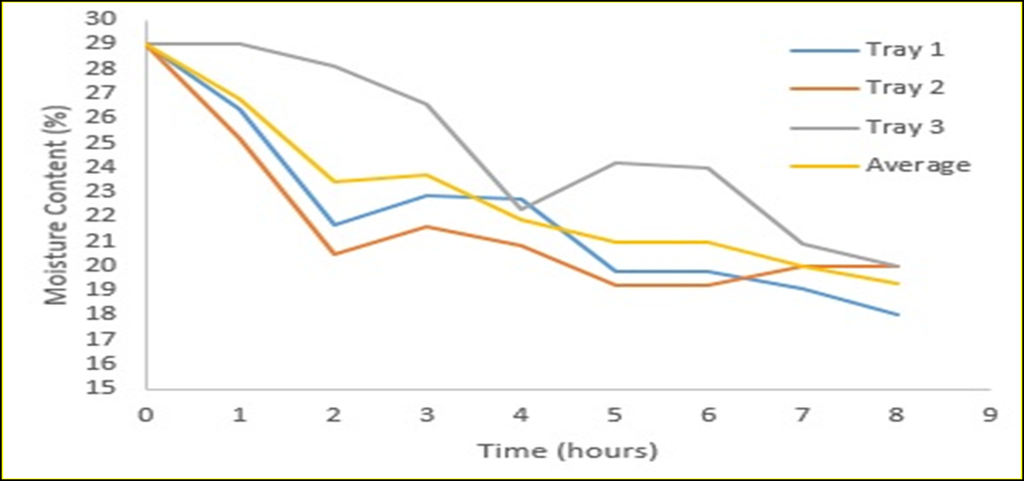
Figure 2: Profile of water reduction during dehydration process

Physicochemical Analysis
Table 2 exhibited the comparison on physicochemical of stingless bee honey between before and after dehydration process. Beside measurement of moisture content, other three characteristic that considered were the sugar profile, HMF content, total phenolic compound (TPC) and the viscosity. It has shown that dehydration process successfully reduce the moisture level of honey to the appropriate level below of 20% rather than its initial after harvest in 29%. The sugar content for fructose, glucose and sucrose also displayed a slightly increment but it’s not too much apparent compare to sugar content in fresh harvested honey. The increasing of sugar content could be due to the removal of water molecule then left the more concentrated sugar in honey. It could be also due to the thermal treatment that has dissolves the sugar crystal nuclei to retard granulation (Escriche et. al., 2009). HMF content exhibited slightly increase after dehydration compare to value of fresh sample. However, it still considered as the low level of HMF which can avoid from the deterioration of active compound in honey. Moreover, the HMF value has obtained for sample before and after dehydration which is 2.27 mg/kg and 2.39 mg/kg respectively are still in the average for the stingless bee honey which is between 2.4 and 16.0 mg/kg as study conducted by Souza et. al. (2006).
Table 2: Physicochemical characterization of fresh and dehydrated honey

Parameter | Fresh-harvested honey | Honey after dehydrate
Moisture Content (%) | 29.00 | 19.00
Sugar Profile  (g/100g)  - Fructose  - Glucose  - Sucrose | 12.39 ± 0.31ª  3.41 ± 0.06ª  2.37 ± 0.06ª | 13.52 ± 0.75ª  3.46 ± 0.21ª  2.48 ± 0.13ª
HMF Content(mg/kg) | 2.27 | 2.39
Total phenolic compound (mg/100g) | 24.47 ± 0.50ª | 25.00 ± 0.57ª
Viscosity at  28°C (poise) | 16.23 ± 1.97ª | 24.30 ± 0.20ª
Measurement of total phenolic content has considered as a simple and fast technique to measure total phenol in complex matrix like honey (Chua et al., 2013). In this study, it has exhibit that honey after dehydrated exhibited slightly increase in TPC content compared to the fresh harvested. The viscosity value also has increased for dehydrated honey with 24.30 ± 0.20 compare to 16.23 ± 1.97 poise from fresh harvested honey. However, what that has been obtained from this viscosity result was contradicted with has reported by Anklam et al. (1998) which the viscosity of honey should be reduce after thermal treated. This was suggested, low viscosity value in fresh harvested honey due to the higher water molecule contain on it. The molecular structure of water is simple since it composes of oxygen and hydrogen bonds so that it can freely flow compare to the complex molecular structure of honey. Due to that, fresh harvested honey in the ambient temperature possessed low viscosity value. Meanwhile, dehydrated honey has removed an amount of 9-10% of water from its original 29%. Thus, it led to the higher concentration of honey with higher viscosity value of 24.30 ± 0.20. This also contribute due to the dehydrated honey possessed complex molecular structure since it contain complex of sugar bond rather than free flow molecule water in the fresh harvested honey.

Conclusion:
Dehydration of stingless bee honey using MARDI dehydrator has successfully reduce high moisture content to the appropriate moisture level of below 20%. The time consumption was 8 hours compare to current approach for remove water content that took greater than 24 hours. Physicochemical characteristic of honey are conserved as fresh harvested honey while the moisture content reduced can avoid from fermentation to be occurred that could deteriorate the enzymes and active compound in honey. This was considered that MARDI dehydrator has meet the requirement to produce consistent high quality stingless’s bee honey.

References:
Almeida-Muradian, L. B. (2013). Tetragonisca angustula pot-honey compared to Apis mellifera honey from Brazil. In P. Vit et al. (Eds.), Pot-honey a legacy of stingless bees New York: Springer, pp: 375–382.
Anklam, E. (1998). A review of the analytical methods to determine the geographical and botanical origin of honey. Food Chemistry, Vol: 63(4): pp: 549-562.
Carlos A.L. Carvalho, Geni S. Sodré , Antonio A.O. Fonseca, Rogério M.O. Alves, Bruno A. Souza And Lana Clarton (2009), Physicochemical characteristics and sensory profile of honey samples from stingless bees (Apidae: Meliponinae) submitted to a dehumidification process, Annals of the Brazilian Academy of Sciences Vol: 81(1): pp: 143-149
Chua, L. S., Adnan, N. A., Abdul-Rahaman, N. L. and Sarmidi, M. R. (2014), Effect of thermal treatment on the biochemical composition of tropical honey samples International Food Research Journal Vol: 21(2): pp: 773-778 (2014)
Escriche, I., Visquert, M., Juan-Borras, M. and Fito, P. (2009). Influence of simulated industrial thermal treatments on the volatile fractions of different varieties of honey. Food Chemistry, Vol: 112 (2): pp: 329–338.
Fallico B, Zappalà M, Arena E And Verzera A. (2004). Effects of conditioning on HMF content in unifloral honeys. Food Chemistry, Vol: 85, pp: 305–313.
Michener, C. D. (2013). The Meliponini. In P. Vit et al. (Eds.), Pot-honey a legacy of stingless bees, New York: Springer, pp: 3–17
Puranik, S., Kumbharkhane, A., Mehrotra, S., (1991) Dielectric properties of honey–water mixtures between 10 MHz to 10 GHz using time domain technique. Journal of Microwave Power and Electromagnetic Energy 26 (4), 196–201
Singleton, V.L., Orthofer, R., Lamuela-Raventos, R.M. (1999), Analysis of total phenols and other oxidation substrates and antioxidants by means of Folin-Ciocalteu reagent. . Methods in Enzymology, 299: 152–178.
Souza, B., Roubik, D., Barth, O., Heard, T., Enriquez, E., Carvalho, C., et al. (2006).Composition of stingless bee honey: Setting quality standards. Interciencia, Vol: 31,pp:867–875
Subramanian, R., Hebbar, H.U. and Rastogi, N.K. (2007), Processing of honey: A review, International Journal of Food Properties, Vol: 10(1): pp: 127-143.
Vit, P. (2013). Melipona favosa pot-honey from Venezuela. In P. Vit et al. (Eds.), Pot- honey a legacy of stingless bees. New York: Springer, pp: 363–373

