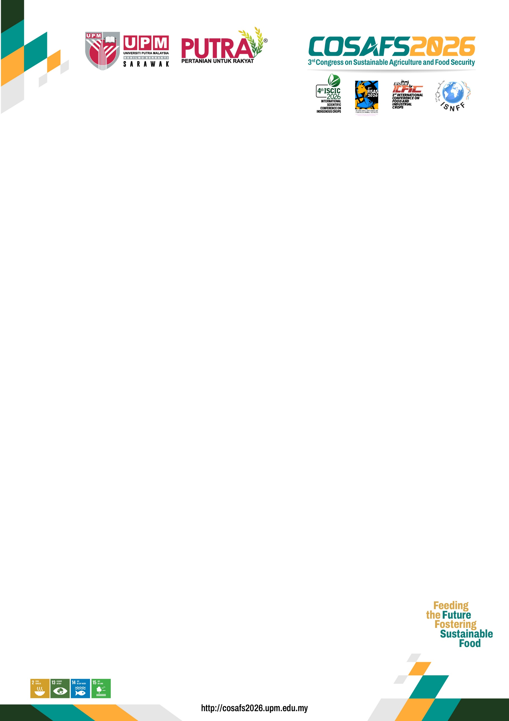
ABSTRACT GUIDELINES
General Instructions
- Authors are invited to submit abstract of original papers on topics related to the conference scope. Please state your conference name acronym, e.g.:
a. International Conference on Food and Industrial Crops (ICFIC2026)
b. International Scientific Conference on Indigenous Crops (ISCIC2026)
c. International Conference on Fisheries and Animal Sciences (FISAS2026)
- The deadline for abstract submission is 31st MAY 2026.
- Experts will review all abstracts and decide whether to allocate them to oral or poster presentation sessions.
- An acceptance letter will be issued within SIX (6) weeks of the submission. All accepted abstracts will be published in the conference e-proceedings.
Preparation of Abstract:
Title
The title must be typed with 14-point Arial, bold, centered, single-line spacing, and capitalized for each word.
Author(s)
The name(s) of the author(s) should be typed with 12-point Arial, centered, and single-line spacing. Indicate the affiliation of the author with a lowercase superscript letter immediately after the name of the author and in front of the appropriate address.
Affiliation Address
The affiliation address of each author must be typed with 11-point Arial, italic, single-line spacing, and centered. The corresponding author should be identified with an asterisk. The email address of the corresponding author should be written after the affiliation address of the author.
Abstract Section
The text of the abstract should be prepared in Microsoft Word document format with 12-point size Arial font italic, justified, and single-line spacing in a single paragraph. The abstract should be a maximum of 250 words in length, including an introduction, objectives, materials and methods, results, and conclusion.
Keywords
Authors should include a maximum of 6 keywords arranged alphabetically below the abstract. The keywords should be written in 12-point Arial font and separated with commas. Avoid repetition of keywords in the title.
Template
Authors are advised to strictly adhere to the format in the template provided (in the Download section).
Submission
The abstract must be submitted in Microsoft Word format (.doc or .docx) and the file should be named using the format Name Conference. For example: Owen_ISCIC2026

