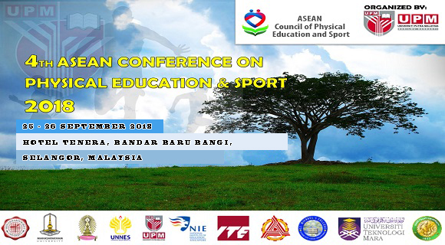

TRANSPORTATION REQUEST

NAME OF CONTINGENT :………………………………………………………………….
DATE OF ARRIVAL : 24 ^{TH} September 2018
PICK UP TIME : 9.00 AM
11.00 AM
1.00 PM

AIRPORT : KLIA or KLIA 2

Name of participants | Passport number | Pick up time | Airport
1.
2.
3.
4.
5.
6.
7.
8.
9.
10.
11.
12.
13.
SENT TO:
ACPES SECRETARIAT 2018
DR. BORHANNUDIN ABDULLAH
borhannudin@upm.edu.my

